Overall idea: use federal as a teaser, but mainly showcase trade war effects

Dataset explanation - 8 federal events, 24 trade war events

1. Event composition - pie chart 1:3
   1. Inputs
      1. Label - ‘Federal’ & ‘Trade Dispute’
      2. Number of these two types events (should be 8 and 24)
   2. Plot method - ‘pie’
2. Stock composition
   1. 30 us stock composition - **pie chart** by industry
      1. Label - industry
      2. Number of stocks each industry
   2. 10 chinese stock composition - pie chart by industry
      1. Label - industry
      2. Number of stocks each industry
   3. 40 combined stock composition - pie chart by industry
      1. Label - industry
      2. Number of stocks each industry
3. Timeline
   1. Federal events in a timeline - **complicated to plot:** https://matplotlib.org/gallery/lines_bars_and_markers/timeline.html
   2. Trade war events in a timeline
   3. Show a “**wordcloud**” of trade war event contents?

Federal - 8 events - 30 U.S. stocks

1. Overall 30 stocks - **Line chart** showing avg ab return progression over 8 events - 1 line
   1. Event names - 8 of these
   2. Average ab returns of 30 stocks - 8 of these
2. By industry
3. cumulative abnormal return (negative x%) over all 8 events - in one **bar chart**
   1. **Label - industry (number of industries)**
   2. **Comu ab return (%)**
4. **Line chart** showing avg ab return progression over 8 events - 7 lines
   1. Event names - 8 of these
   2. Average ab returns for each industry - number of industries

Trade War - 24 events - 30 US stocks, 10 Chinese stocks

0. Wordcloud of trade war - input: texts of events

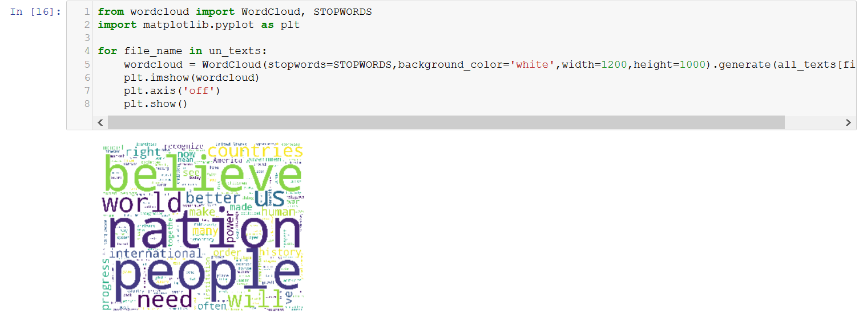

1. By country
   1. Cumu ab return - **bar chart** (x-axis, US/China; y-axis, cumu ab return)
   2. Avg ab return vs. event - **line chart** (x-axis: event/date; y-axis: avg ab return)
2. By industry
   1. Cumu ab return - **bar chart** (x-axis, US/China; y-axis, cumu ab return)
   2. Avg ab return vs. event - **line chart** (x-axis: event/date; y-axis: avg ab return)
3. BY country and industry - something like this - x-axis industry, tag country:

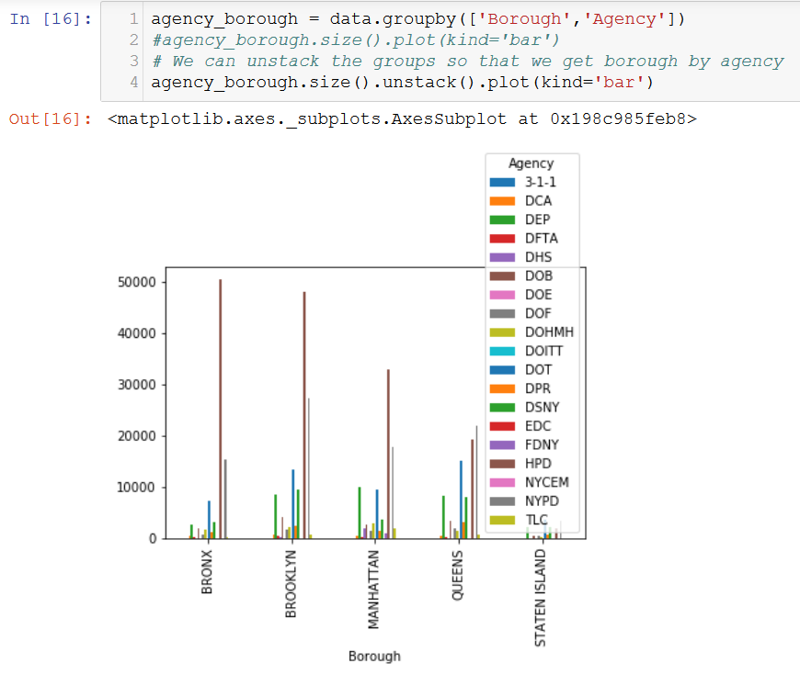

Conclusion

Federal

1. Overall - federal rate hikes have **negative** effect on stocks’ return
2. Industry - which industries are affected by federal rate hikes the most/least
3. Industry - as events continue, negative effect strengthens or alleviates

Trade war -

1. country -
   1. affect US or China more
   2. Which event affects the most
2. Industry
   1. Which industries are affected by trade war the most/least

Scrap:

1. Individual event - use event 1 as the main example (other 7 events optional unless time permits), show the following:
   1. 30 stock’s abnormal return on one **bar chart**
   2. Cluster average abnormal return by industry - **bar chart, ordered**
   3. A **histogram** - how many companies fall - 0-2%, 2-5%, etc.